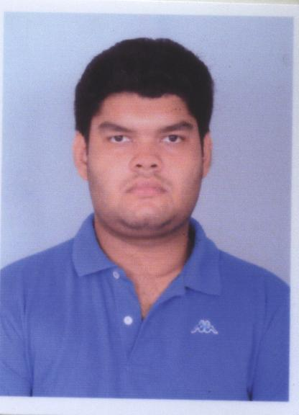
CURRICULUM VITAE

Name: - Padmanava Ganguly
Dept : - Electronics and communication engineering
Year of passing : - 2012
Degree : - B-Tech
College: - Aryabhatta Institute of Engineering & Management, Durgapur
E-mail :- padmanavag48@gmail.com
Ph No : - 8961706758

TECHNICAL EXPOSURE:
Programming Language : c
Subject : Data Structure (D.S.), Optoelectronics and Microelectronics

EDUCATIONAL QUALIFICATION:

GENERAL:

Year of passing | School | Examination | Board | Percentage
2007 | St augustines days. School | 10+2 | CISCE | 68.28
2005 | St augustines days school | 10 | CISCE | 78.16

TECHNICAL:
Year of passing | College | Examination | Board | Stream | Semester | SGPA | YGPA
2012 | Aryabhatta Institute of Engineering & Management, Durgapur | B. Tech | WBUT | Electronics and communication engineering | 1st | 7.40 | 7.59
 |  |  |  |  | 2nd | 7.77 | 7.59
 |  |  |  |  | 3rd | 7.80 | 7.97
 |  |  |  |  | 4th | 8.13 | 7.97
 |  |  |  |  | 5th | 8.08 | 7.89
 |  |  |  |  | 6th | 7.72 | 7.89
 |  |  |  |  | 7th | 8.26 | 8.18
 |  |  |  |  | 8th | 8.1 | 8.18

PERSONAL PROFILE
NAME : Padmanava Ganguly
DATE OF BIRTH : 07-12-1988
FATHER’S NAME : Mr. Samir Kumar Ganguly
SEX : Male
NATIONALITY : Indian
LANGUAGES KNOWN : Bengali, English (Read, Write, Speak) & Hindi (Speak)
HOBBIES : Self Scanning
ADDRESS : P.O. - Ichapur Dist: - 24parganas (North)

DECLARATION: I hereby declare that the information furnished above is true to the best of my knowledge.

Date: 16/01/2013
Place: kolkata
Padmanava Ganguly

